Guide Development

jWebSocket
SMS Gateway
Mayra Eva Marañón Rodriguez

- Overview
The manual describes how to modify the developer's code and use SMS Gateway application developed on the framework jWebSocket. This document has been created for software developers to create, assemble and deploy the application using the framework jWebSocket. It is an SMS gateway can be used as media for standalone applications, and functionality that enriches applications or as a means to send SMS messages from a web page. It is a gateway that has captcha mechanism is a challenge-response test used to determine when the user is human or not. This functionality is used to prevent robots, also called spambots, can use the SMS service provided by the SMS gateway. It differs from other SMS gateways because it works in real time through the new WebSocket protocol that makes it possible. It was developed using the framework jWebSocket, allowing the user to test the potential offered by this framework.
- Infrastructure, Model, Approach.
The SMS gateway application implements the layered architecture, allowing separate business logic from the logic of design. The architecture of the gateway is divided into three main layers: Browser or Browser that represents the presentation layer, server layer jWebSocket representing the Business and Supplier layer that represents the connection to the mobile network. The application does not have the data layer and unused Database to function. Furthermore, the development can be carried out at various levels and in case there occurs a change, affects only the required level.
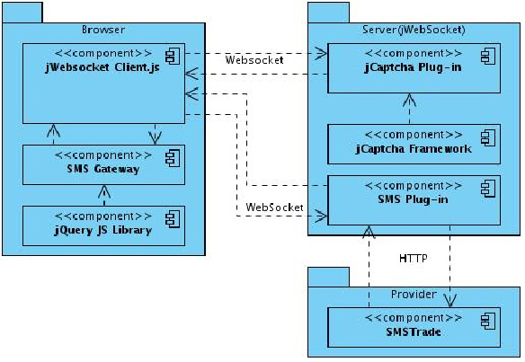
The SMS gateway application uses features of the jQuery JavaScript library in addition to the framework JCaptcha. The package contains browser components that must interact with the client. The server package (jWebSocket) contains the components that interact on the server for JCaptcha components and plug-in framework JCaptcha recent exchange with each other to generate the captcha image. There is also the SMS Plug-in component that connects via HTTP Provider package which has the component SMSTrade latter interact with each other to make shipments of SMS, bulk SMS, SMS and longer.
- Requirements and prerequisites
The requirements for the continued development of the SMS Gateway application are:
- Connecting to the network.
- Mobile phone provider.

Configuring Maven
The modules jWebSocketSMSPlugIn and jWebSocketJCaptchaPlugIn are configured via the pom.xml file, which is an XML representation of the Maven project within the project folder to configure the dependencies and basic properties of it. This file contains various components of Maven, including maven-jar-plugin that lets you export all the fonts in the file jWebSocketServer.jar, then you will see how it is used:
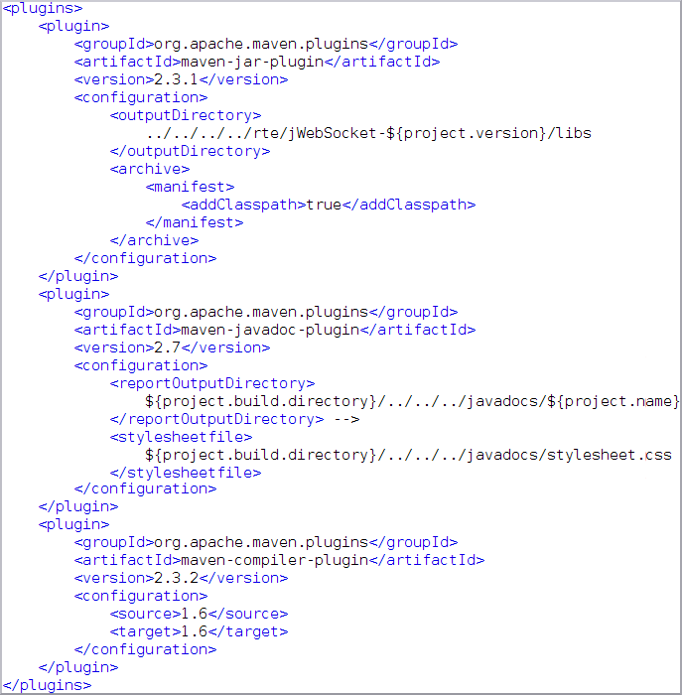

After compiling the project, the sources go to the folder rte/jWebSocket-1.0/libs/ in the file jWebSocketServer.jar.
Another important point to be addressed within the project settings are the dependencies that are included in the section <dependencies> </dependencies>
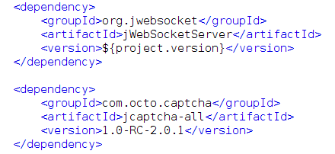

- Modules, Structure
Project Name | SMS Gateway
Location of the sources in the SVN server | Server | Client
SVN branch | jWebSocket-1.0

On the client side:
We used the jQuery framework. The client libraries and classes to implement SMS gateway available in the JavaScript language and are stored in the folder/demos/ jwsSMSGateway.

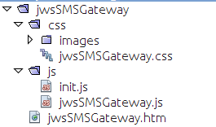

It also makes use of css and htm files to the user interface of the application:
File | Description
jwsSMSGateway.htm | This file is set to any HTML application.
jwsSMSGateway.css | Includes HTML css for the application

On the server side:
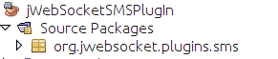
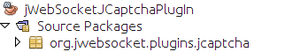
There is a plugin that receives and sends tokens of actions performed by users regarding the sending of SMS and other plugin which receives and sends tokens of actions performed by users regarding the challenge test image captcha. This server is structured as follows:

Source code structure
Client:
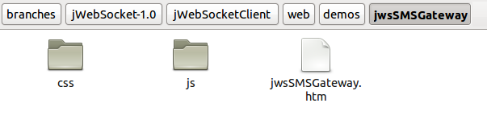
Description of elements:
css: This directory contains all the css files and a directory with the images used in the application.
js: This directory contains all the libraries and classes used for application development.
jwsSMSGateway.htm: It is a hypertext file. These are usually static content, not dynamic. Includes HTML application.
Server:
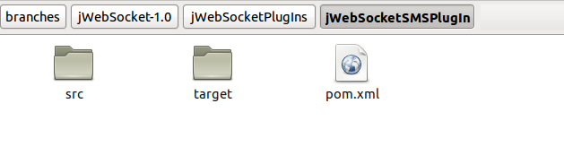

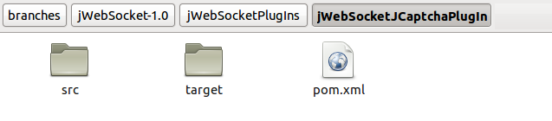
Description of elements:
src: This directory contains all the source code of classes and libraries of the solution.
target: This directory temporarily stores the compiled source code, its content is not included in the version control.
pom.xml: Module configuration file generated by the tool Maven. This file defines among other things, the dependencies.
- Source code
View Standard Template Code:
http://repo.hab.uci.cu/svn/tesis/Segundo_Corte_de_Tesis/JWS/Mayra%20Eva%20Mara%C3%B1%C3%B3n%20Rodriguez/2do%20Corte/Plantilla Estandar de codigo.doc
Detailed description of the application code
Server: The fundamental methods in jWebSocketSMSPlugIn the server are:
Type | Method | Description
void | processToken ( PlugInResponse aResponse, WebSocketConnector aConnector, Token aToken) | Processes the received token and adds or deletes a connector to the customer list. The token can be sms.
void | sendSms(WebSocketConnector aConnector, Token aToken) | Creates the provider to which the token is sent with information on the SMS

Server: The fundamental methods in ProviderSmstrade the server are:
Type | Method | Description
String | getErrorMessage(String aCode) | Answer the type of error occurred in sending the SMS
Token | sendSms(Token aToken) | SMS data encoded in UTF-8, open the HTTP connection that sends to the supplier SMSTrade SMS and get the status.
Server: The fundamental methods in jWebSocketJCaptchaPlugIn the server are:
Type | Method | Description
void | processToken ( PlugInResponse aResponse, WebSocketConnector aConnector, Token aToken) | Processes the received token and adds or deletes a connector to the customer list. The token can be either getcaptcha or validate.
Token | generateCaptcha(Token aToken, WebSocketConnector aConnector) | Generate image captcha challenge created by the user response
boolean | validateCaptcha(String captchaId, String inputChars) | Validates if the password entered by the user of the challenge response is correct captcha image.
Client: The methods on the client side that describe the most important features are:
Method | Description
getCaptcha() | Get the captcha token server image.
registerEvents() | Validate the password entered by the user to meet the challenge-response captcha image and sends the data satisfactory to the SMS server.

- Interfaces
Protocol Used
The SMS gateway application being developed on the framework jWebSocket, used to establish communication, WebSocket protocol, a technology that provides a bidirectional communication channel and full-duplex over a single TCP socket.
Programming Model
SMS Gateway is based on the doctrines of the event-driven programming, which is a programming paradigm in which both the structure and implementation of the programs are determined by events occurring in the system, defined by the user or they same cause.
- Frameworks, libraries and tools

Frameworks:

jWebSocket
jWebSocket framework is an open source web application development based on stationary and mobile Java on the server side and JavaScript on the client side. establishing a model jWebSocket token as abstract data through a hierarchical structure and API provide methods to access the contents. In order to make an abstraction in the handling of different formats, the framework converts the data packets incoming and outgoing tokens.
jWebSocket as a Web server provides an important set of features and its extensible architecture with plugins to easily add additional features to an independent system. In a cluster components can be used as services, so jWebSocket perfectly compatible with SOA in an environment based on events. These features show the strength and flexibility of the framework for the development of stationary and mobile web applications, multi-sectoral and compatible with all browsers. The framework jWebSocket through WebSocket communication, provides high levels of speed, scalability, security and work in real time.

jCaptcha
JCaptcha framework is a robust, reliable, developed in Java. This provides access to captcha implementations also provide multiple types of challenge as text, picture and sound. The framework provides JCaptcha prevents applications that make use of it may be vulnerable under attack robots. The framework provides a simple way to parameterize new captchas with engines and components JCaptcha. The framework clearly separates JCaptcha services, service integration devices and sub-modules.

jQuery
It is a library or JavaScript framework. Simplifies the way people interact with HTML documents, manipulate the DOM, handling events and develop animations, achieving great results in less time and space. Its main feature is that you can change the contents of a web page without recharging, by manipulating the DOM and AJAX requests. It also allows interactivity and DOM tree modifications, including support for CSS 1-3 and basic XPath component. It has several utilities to obtain information from the browser, operating with objects, vectors, functions, among others. It is compatible with Mozilla Firefox 2.0 +, Internet Explorer 6 +, Safari 3 +, Opera and Google Chrome 10.6 + 8 +.
libraries:
The libraries and classes for the extension SMSGateway customers are based in Java Script and are stored in the file jwsEventsPlugIn.js. The requirements of external libraries in the client side are:
Libreries | Description
jQuery.js | Version 1.5.1, GPL and MIT. To work with the client-server connection.

- Database and data persistence (if applicable)
SMSGateway module does not require the use of a database operation.
- Hardware
SMSGateway module does not require the use of additional hardware to operate.

